**Project AWS**

**Part 1:**

**>> Cloud Formation Stack**

**>> Terraform**

**>> Ansible**

**Part 2:**

**>> Route 53 for VPC internal communication**

**>> MySQL DB access**

**>> User to manage infrastructure**

**>> S3 Bucket for logs**

**>> EC2 instance permission for s3**

**Part 3:**

**>> Cloud watch for:**

* **CPU Utilization**
* **Disk Usage**
* **Netwok I/O**
* **Memory usage**

**Part1:**

**Cloud Formation:**

1. **Creating VPC, 1 Public Subnet, 1 Private Subnet, Internet gateway, Routing tables and NATgateway**

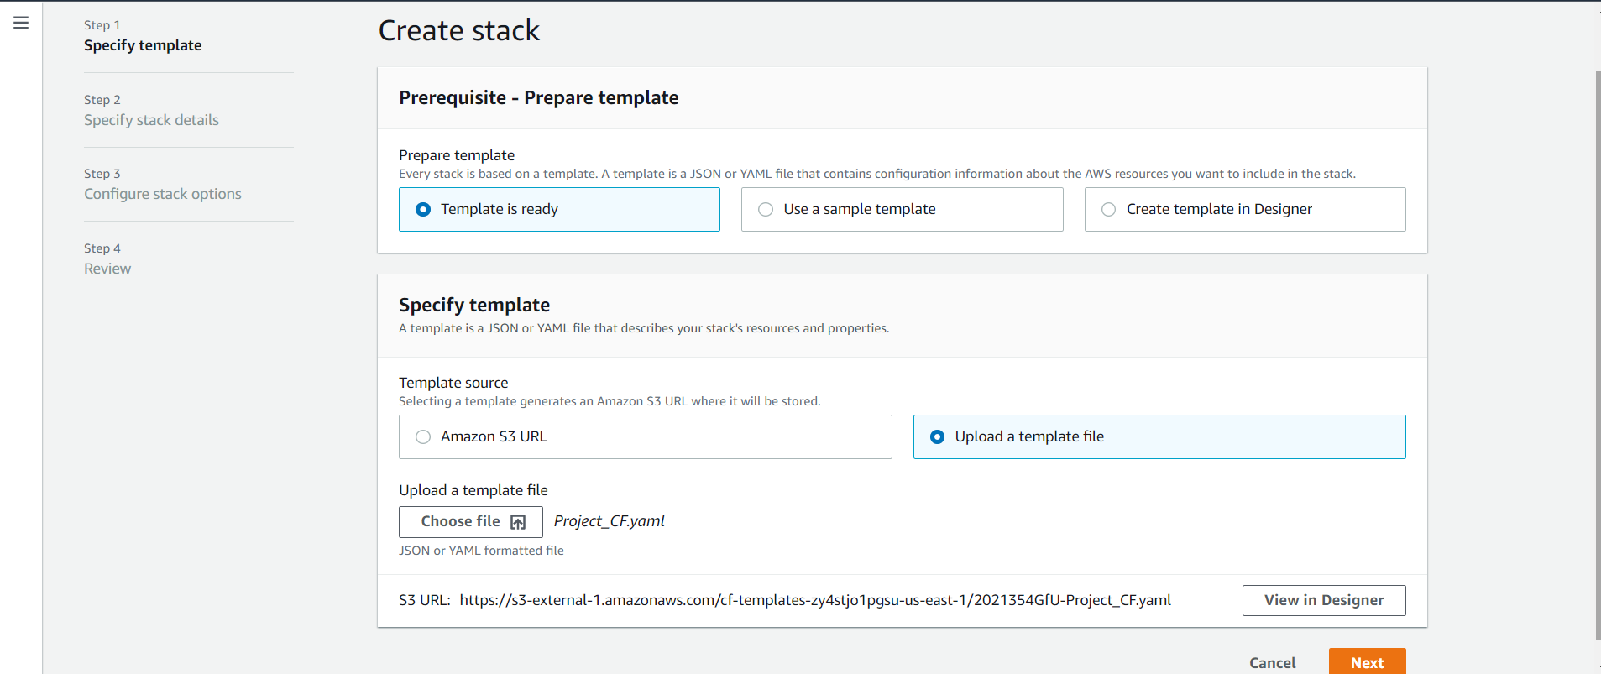

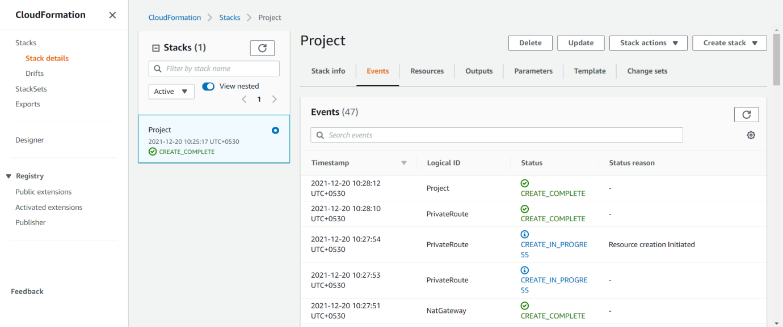

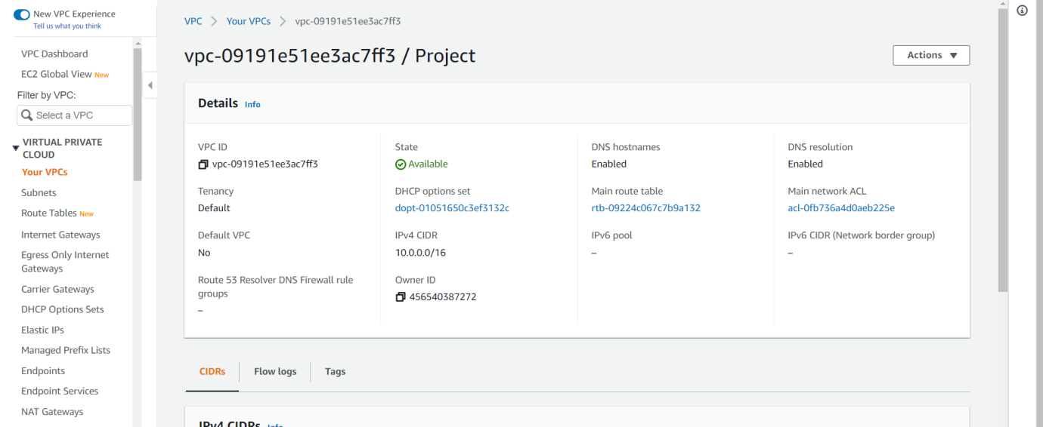

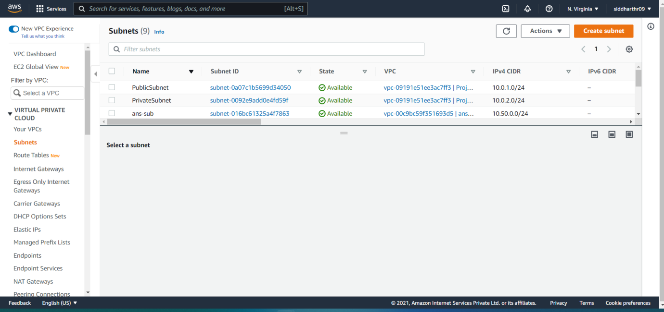

**Terraform:**

1. **Create AGS in public subnet**
2. **Load balancer**
3. **1 instance in private subnet**

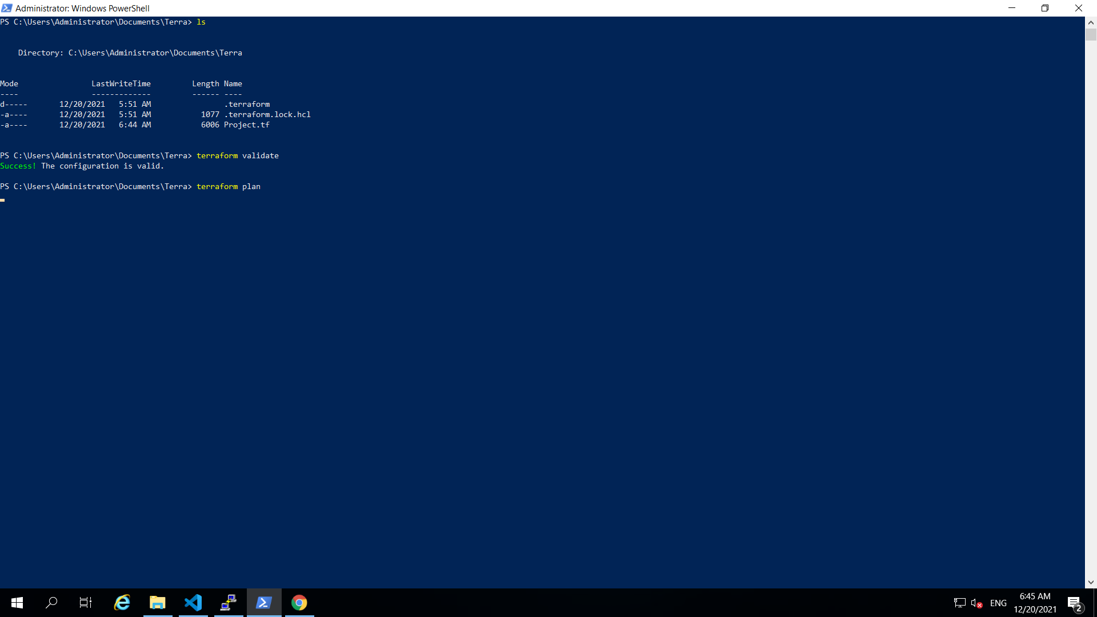

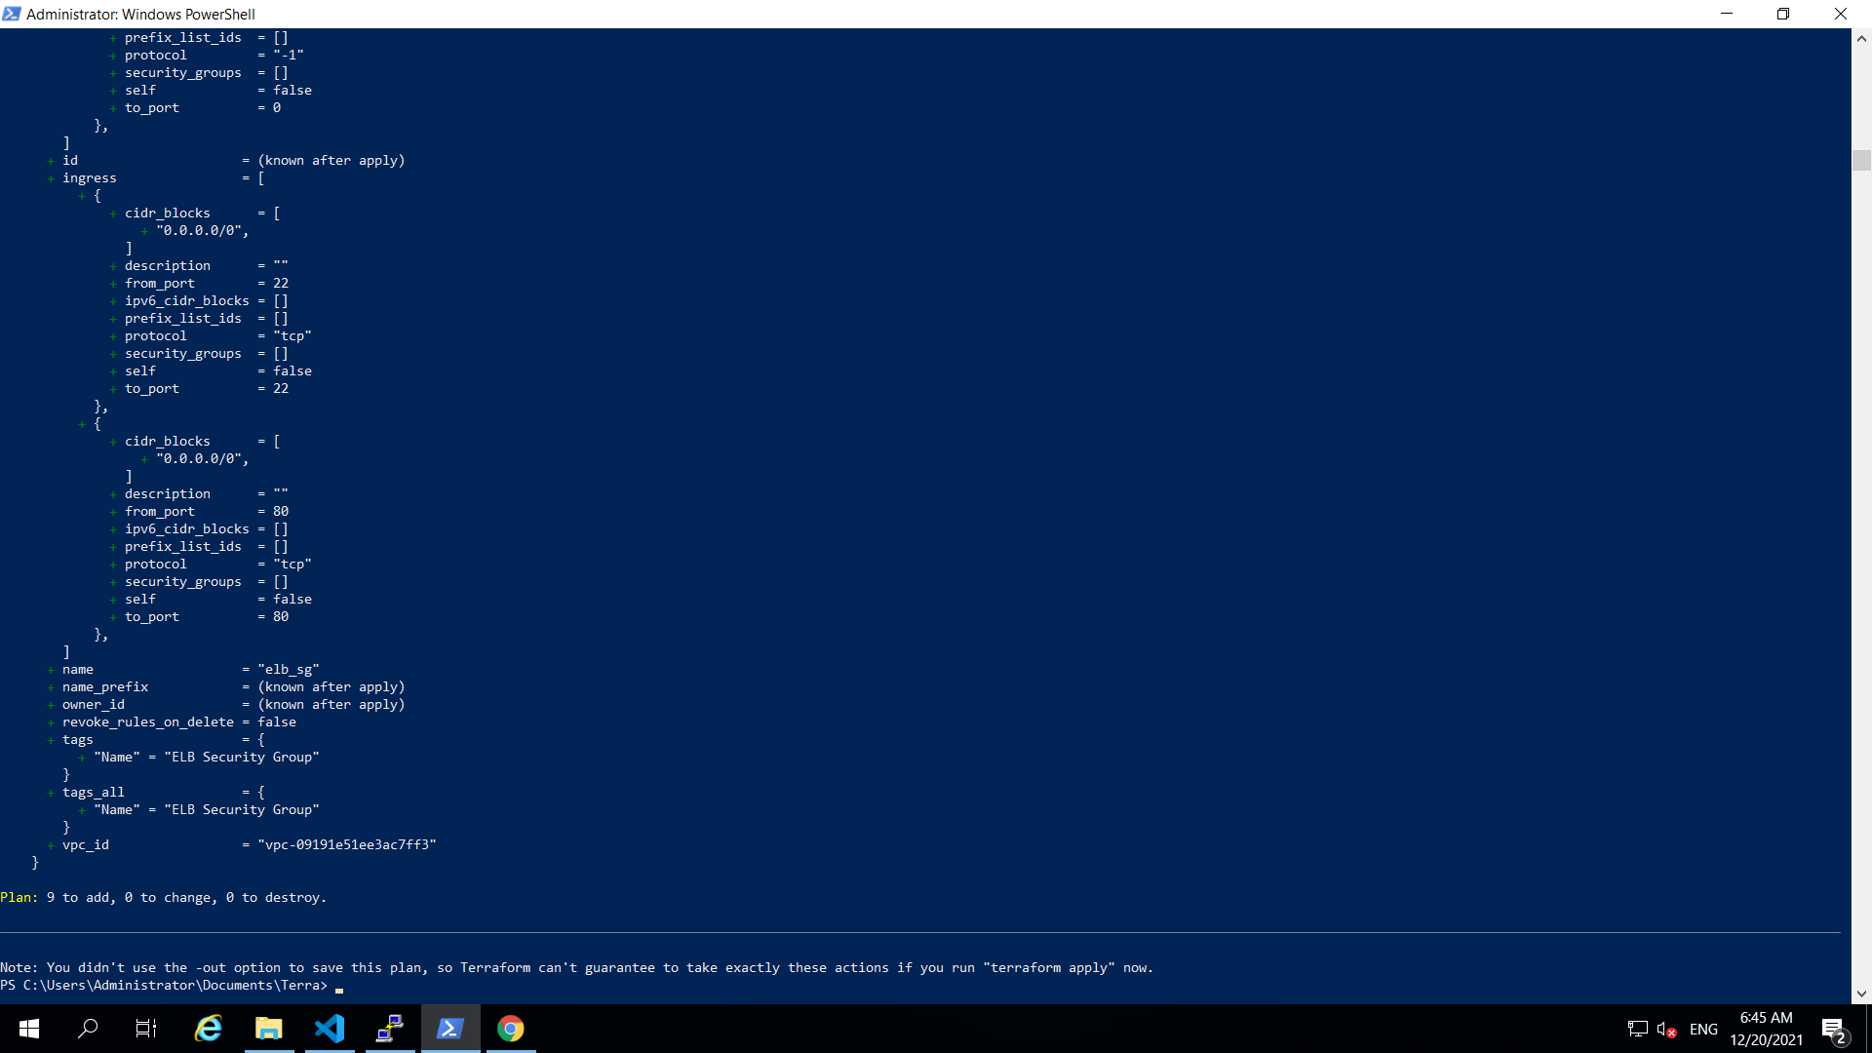

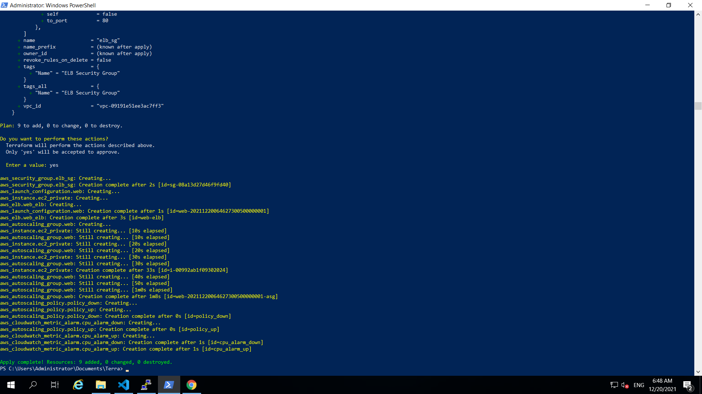

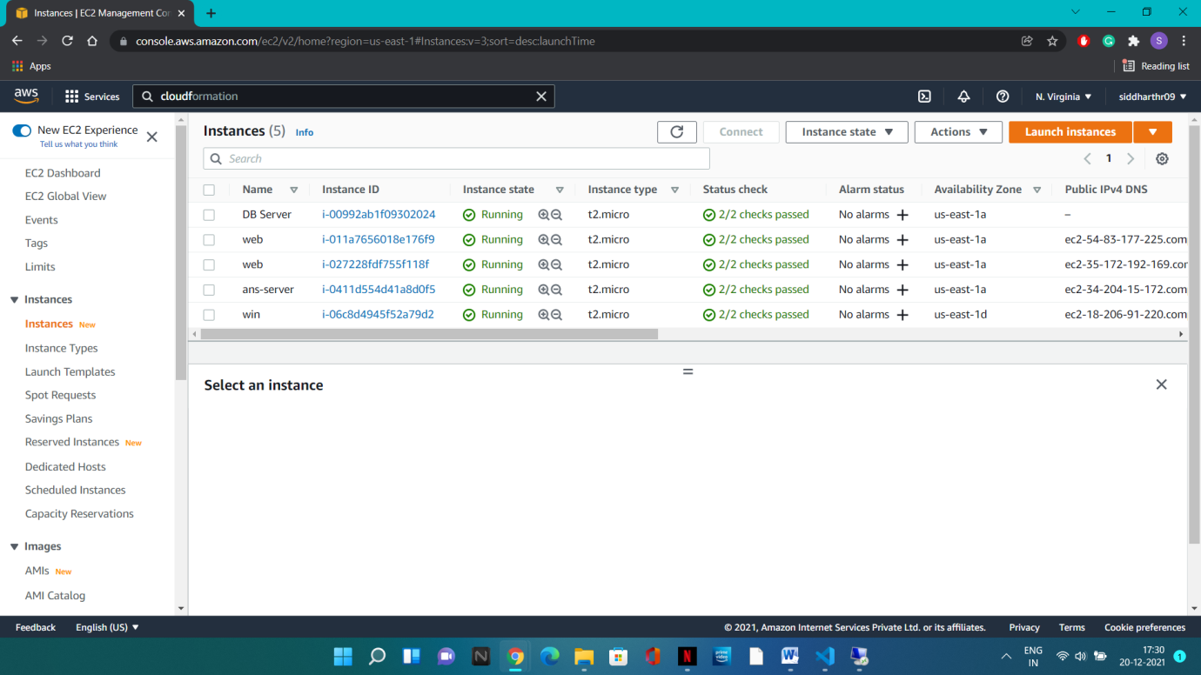

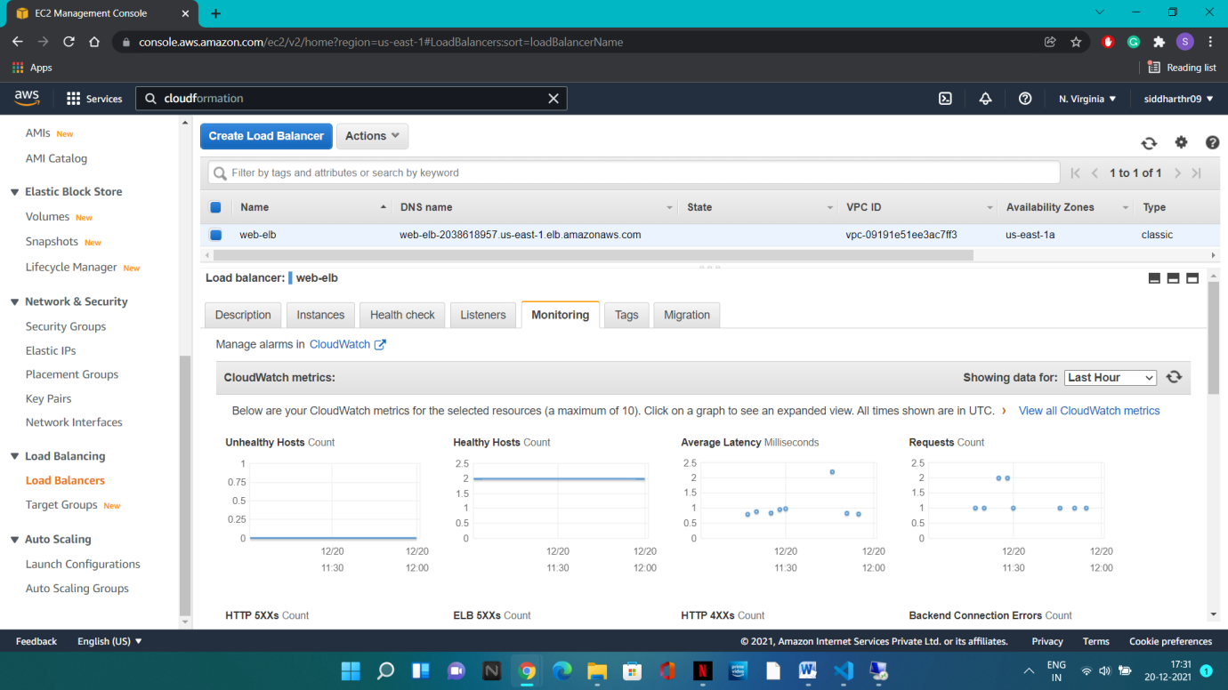

**Ansible:**

1. **Install Apache on ASG Web Servers**
2. **Copy Index.html file**
3. **Install MySQL in private DB**

**The YAML file:**

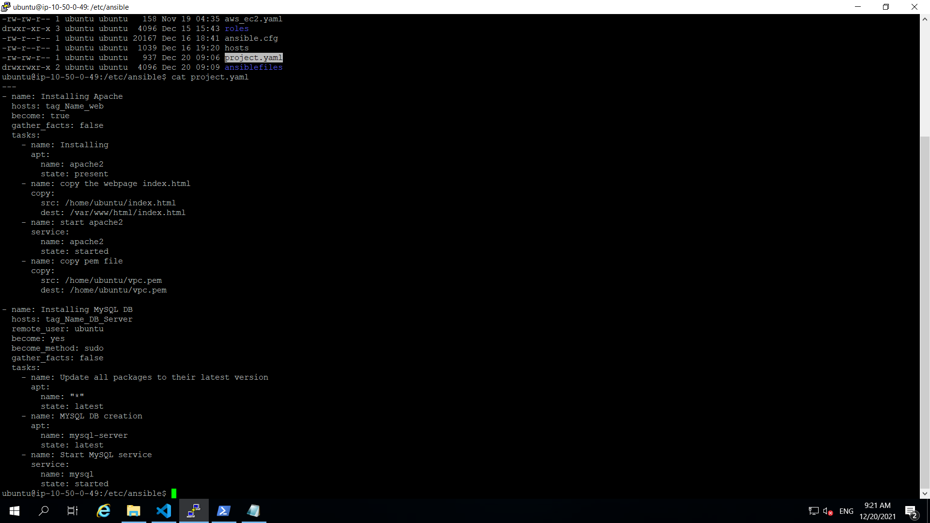

**Servers working on:**

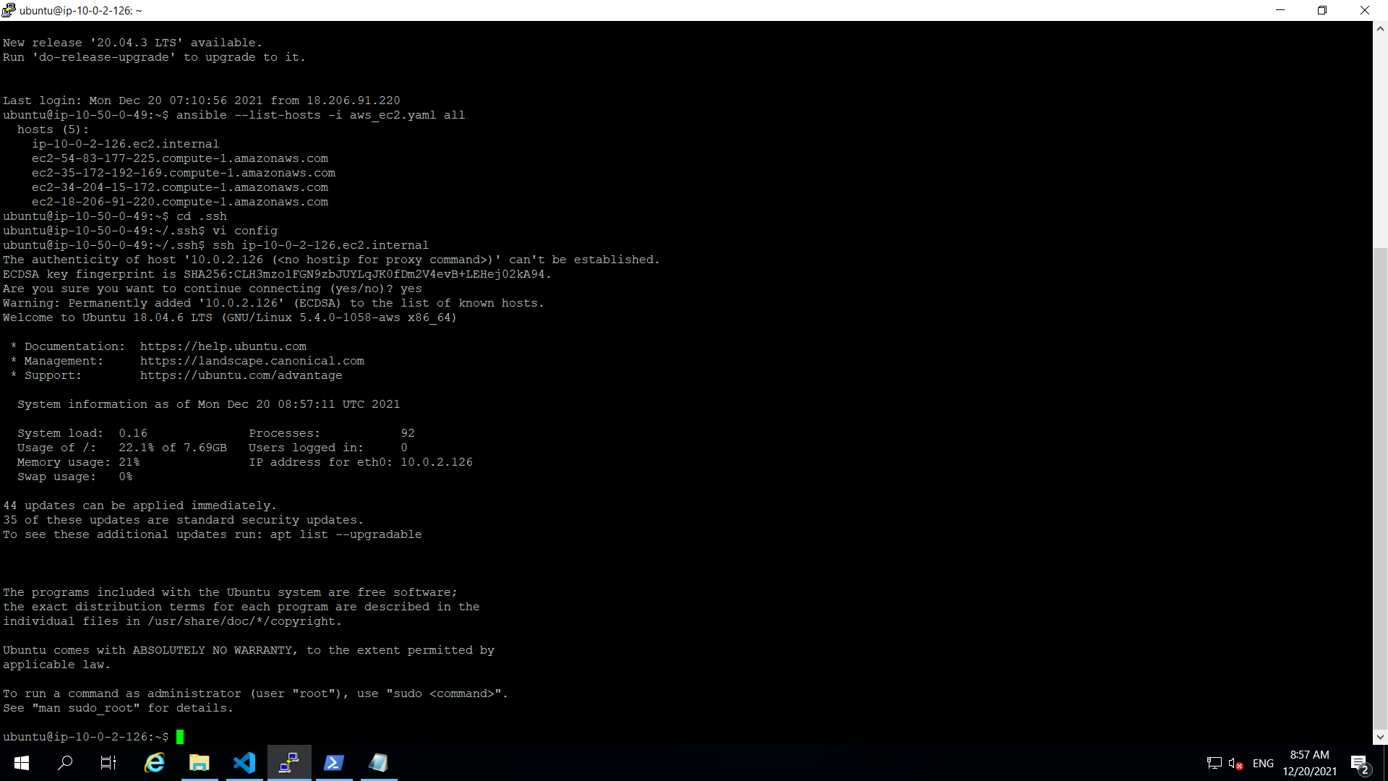

**Running Play-Book**

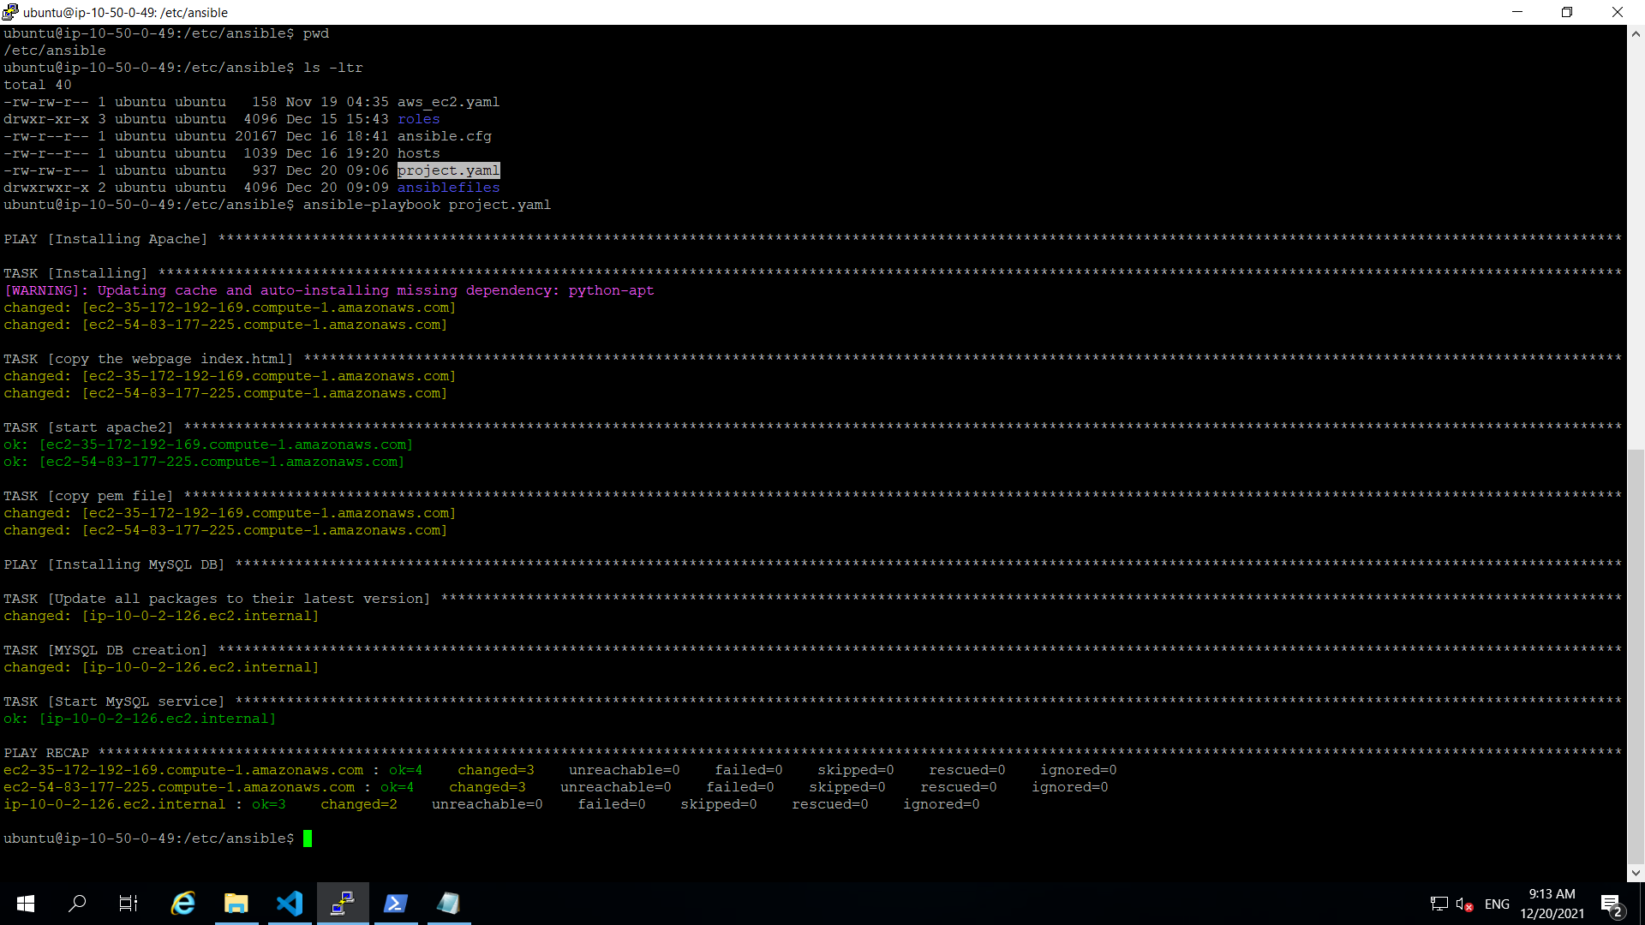

**Checking Apache status:**

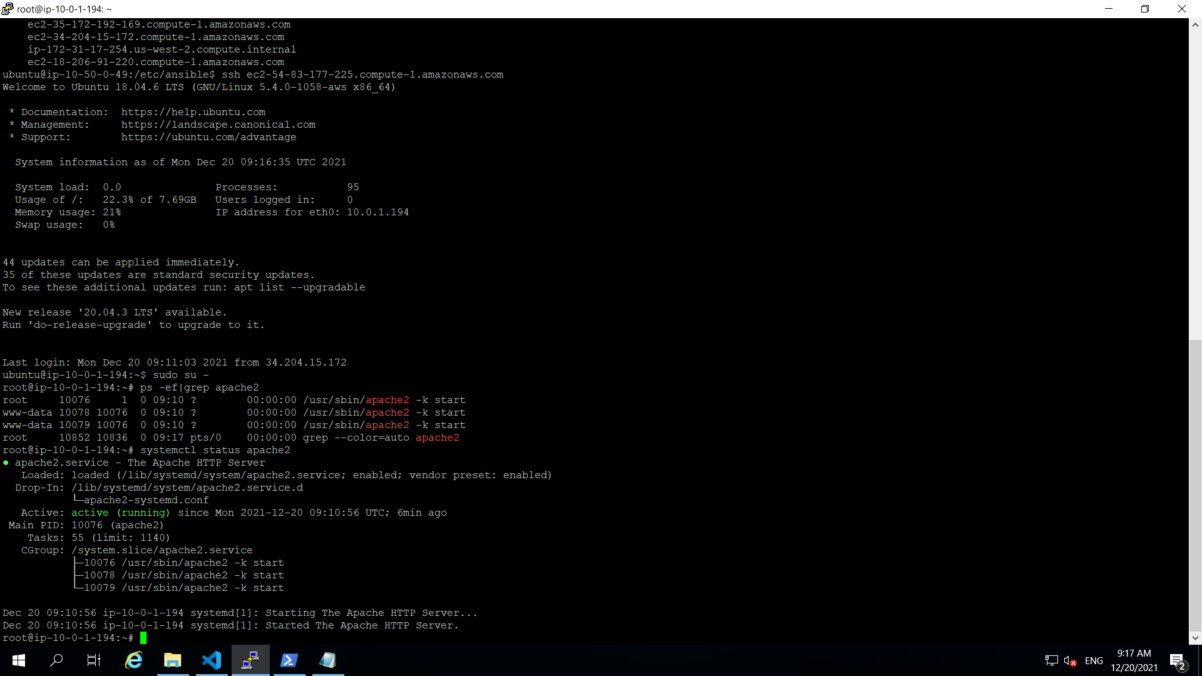

**Checking Index file:**

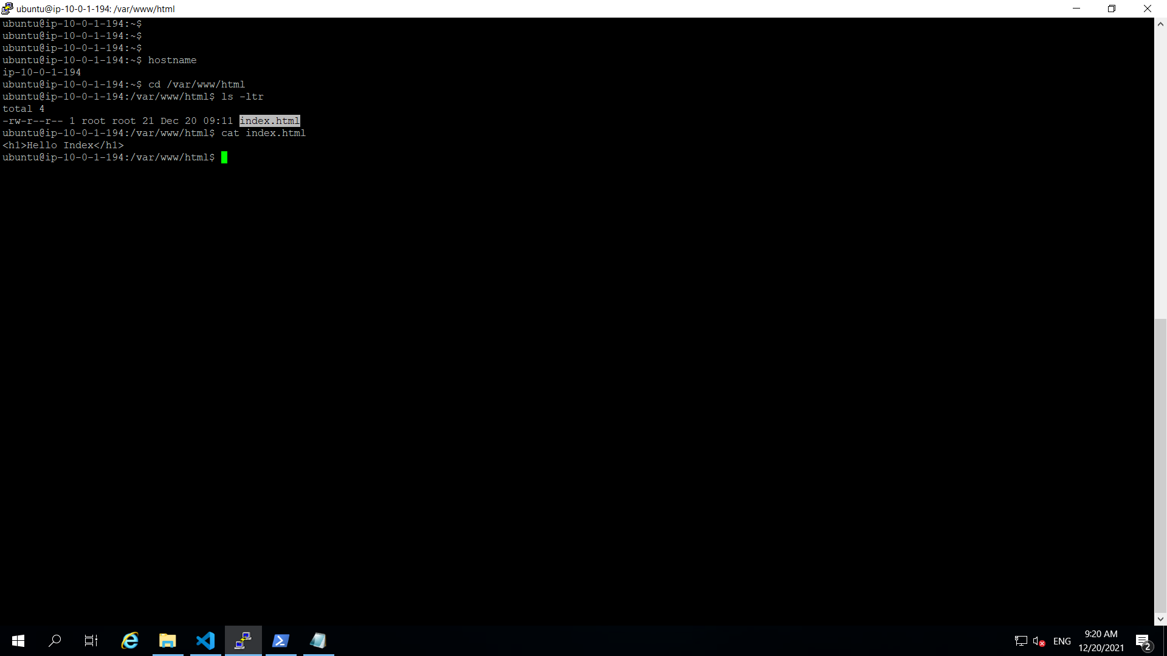

**Checking MySQL DB connection:**

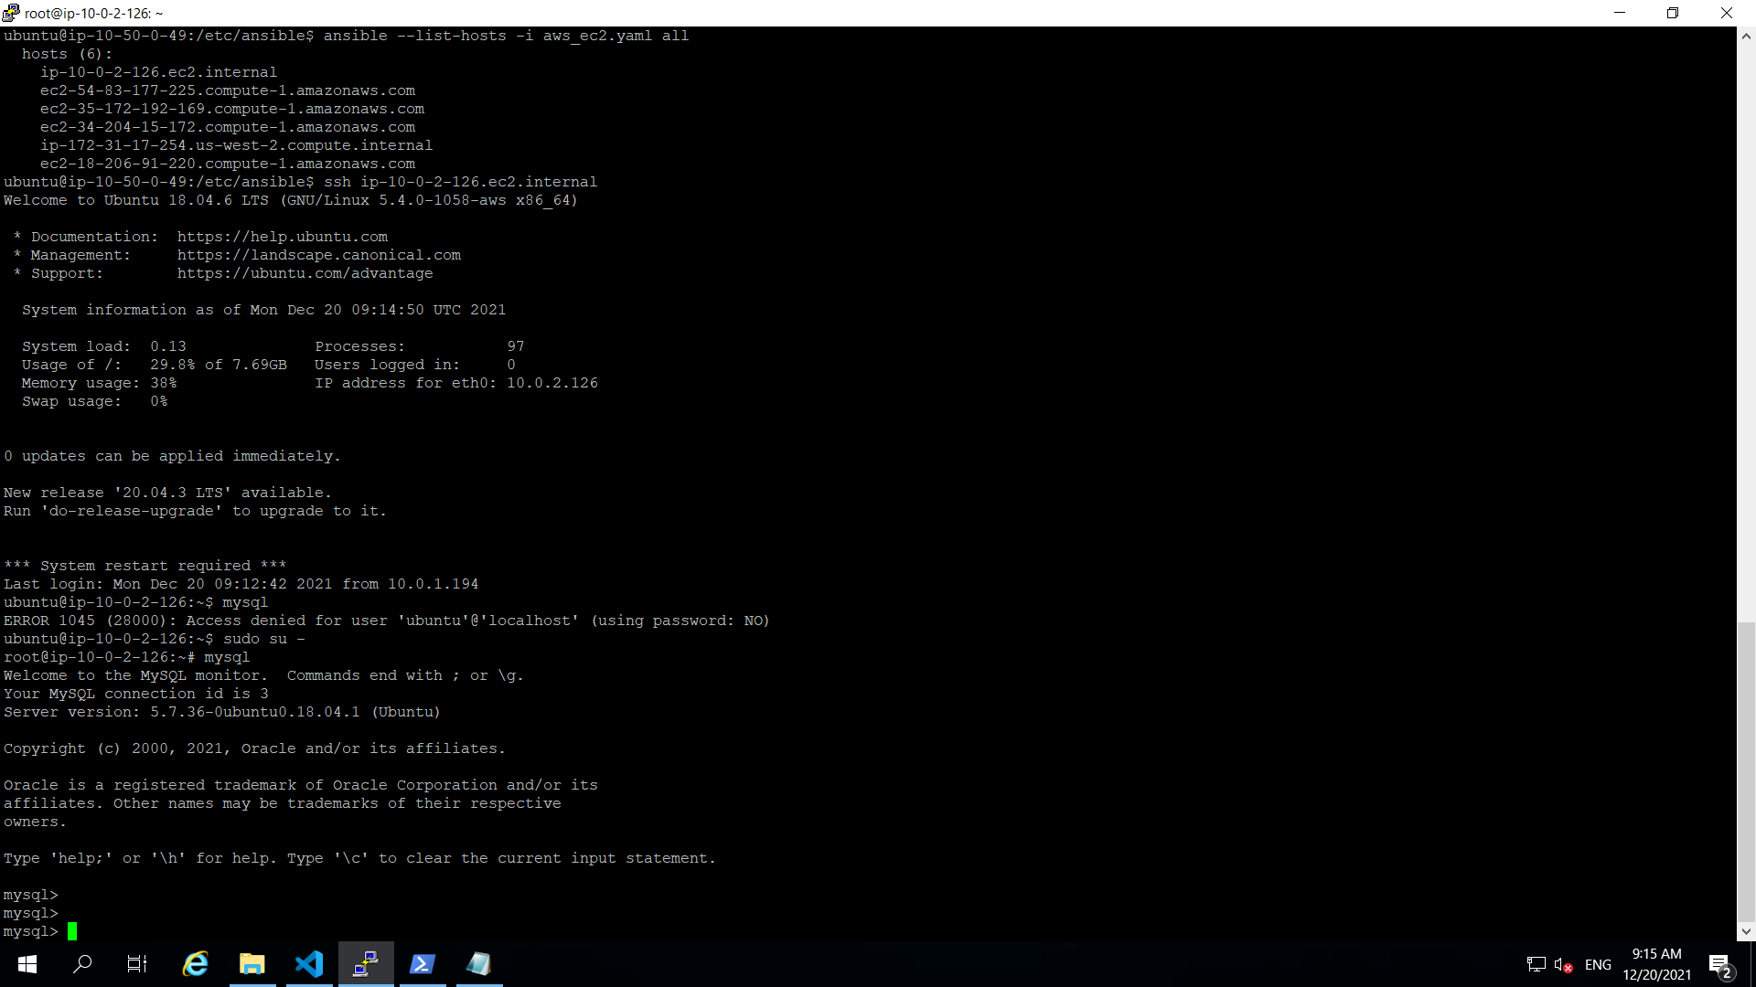

**Configuration of Ansible.cfg**

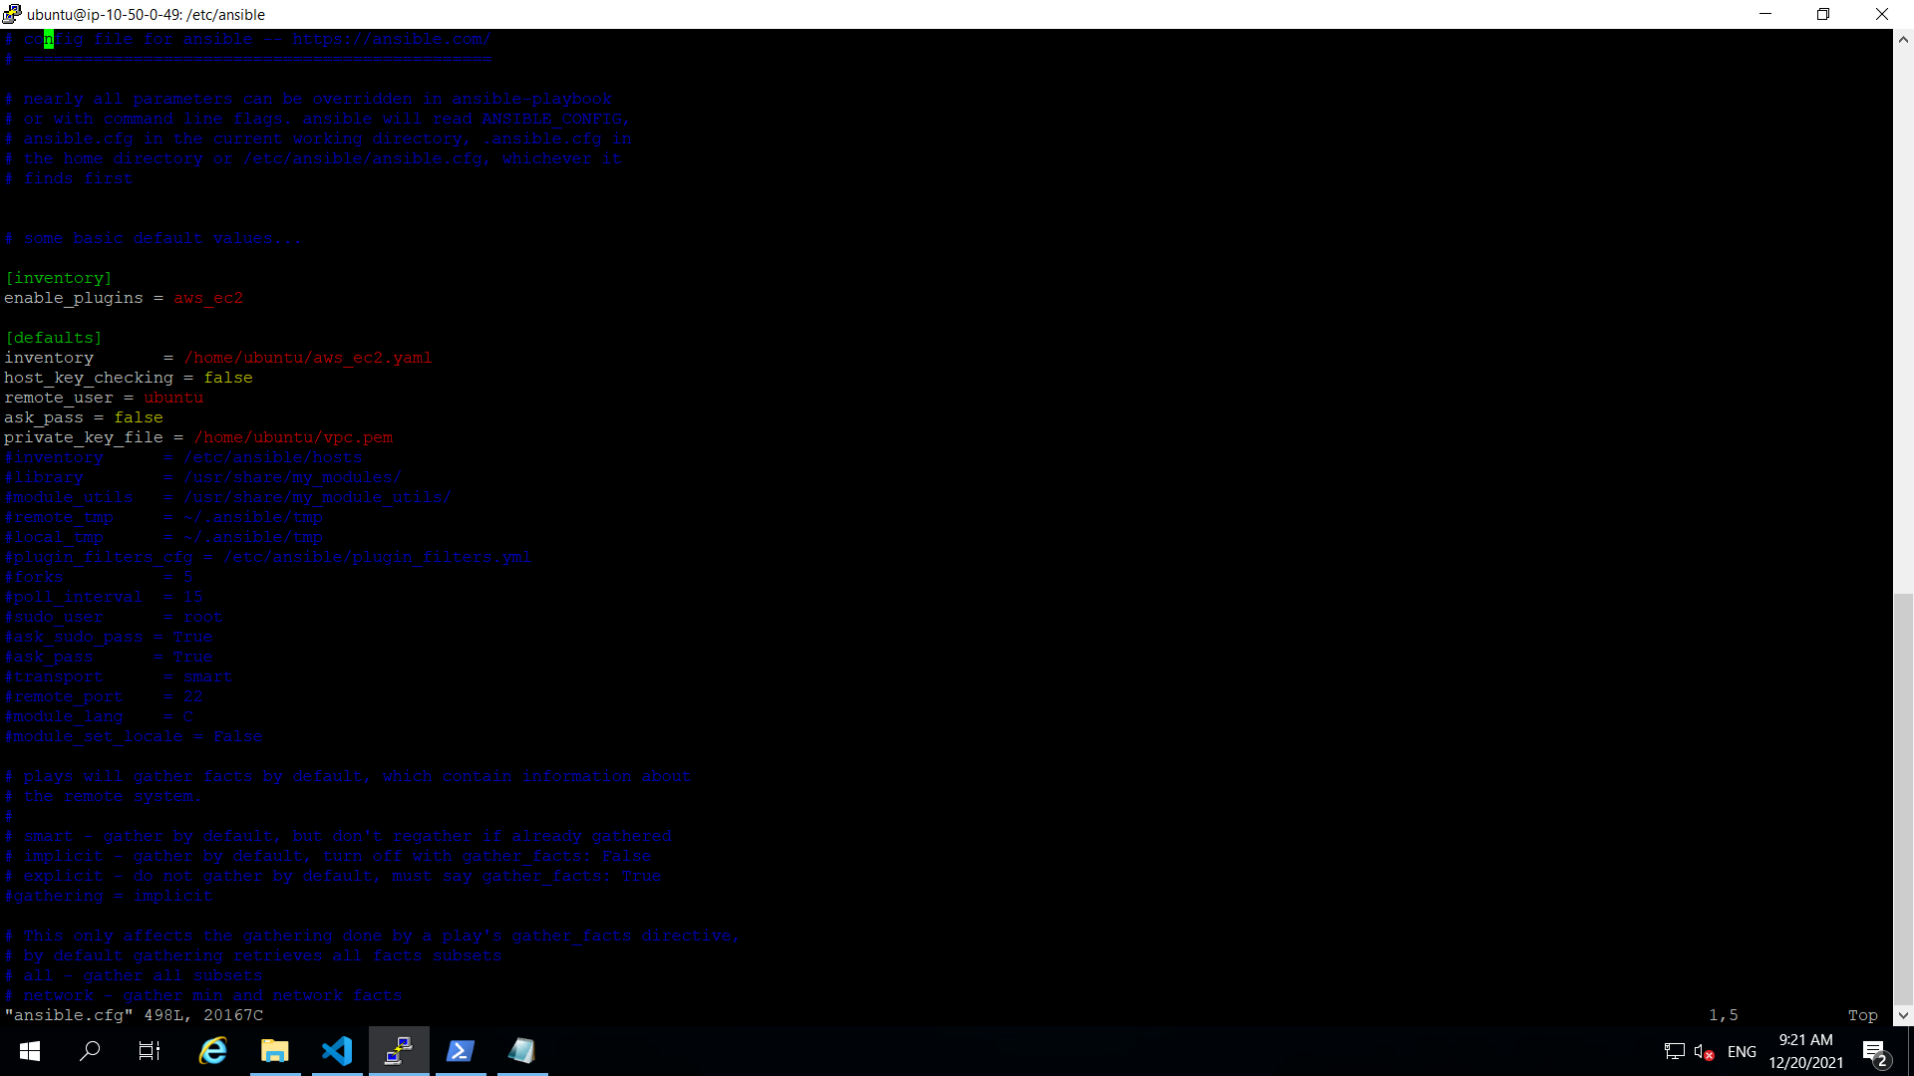

**aws_ec2.yaml file:**

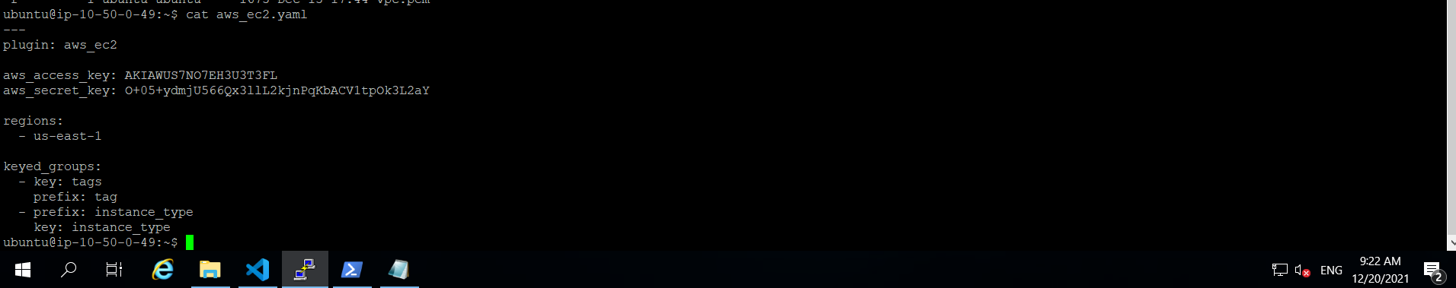

**Part2:**

1. **Route 53:**

**Creating Records for Web server instances and DB server instance(with private IP)**

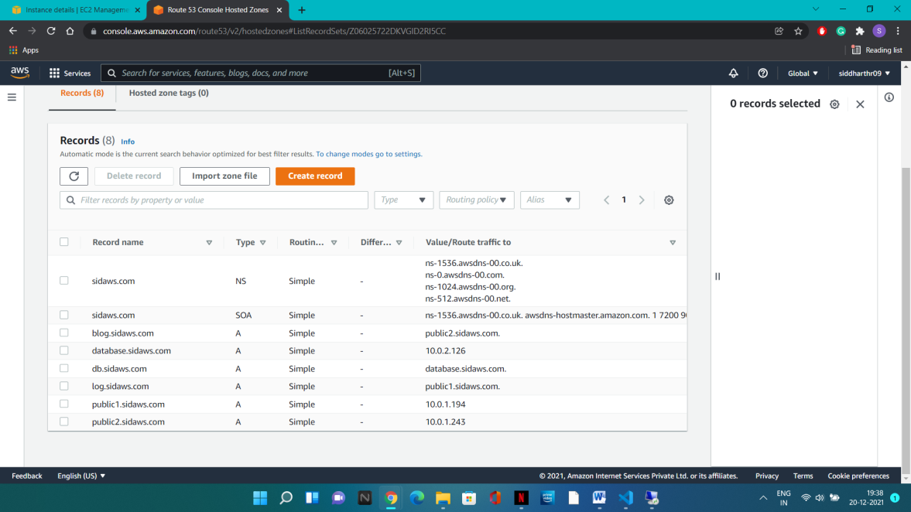

**For Example:**

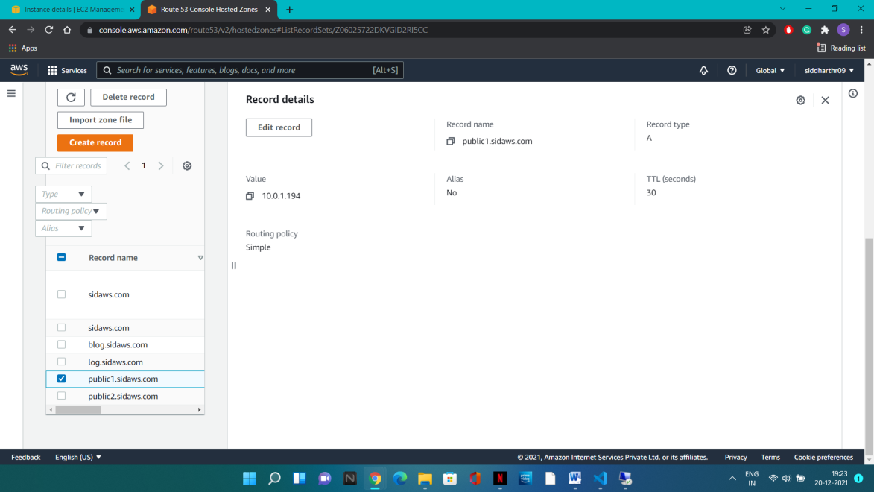

**Create another set of records pointing to previous records (alias to another record)**

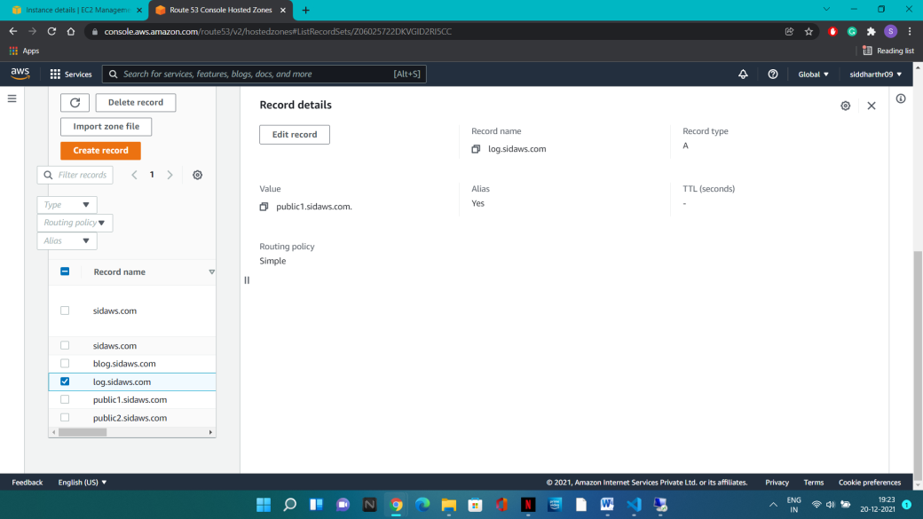

Testing connections:

Ping and ssh to one web server to other with domain name:

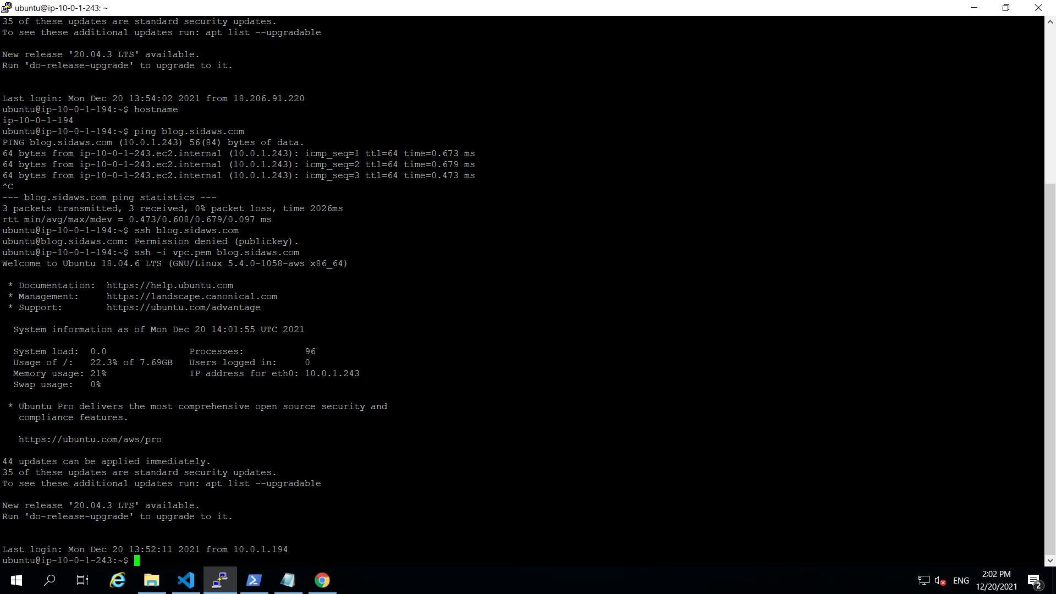

Testing ssh and ping connection to DB domain name:

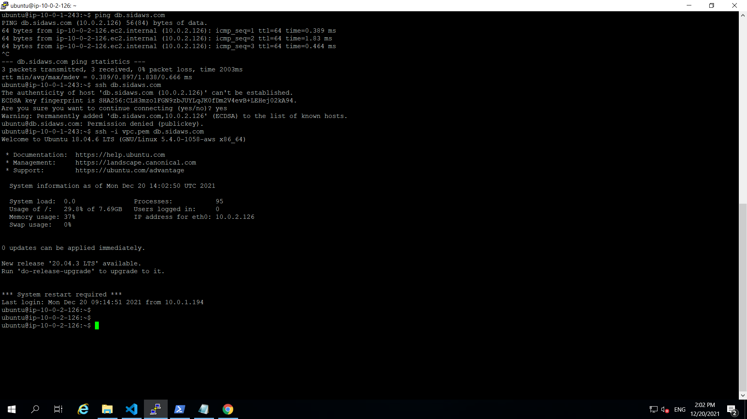

1. MySQL DB access:

Creating a security group for DB server. In whch, the inbound rule will depend upon the elb security group. So, only instance which will be created via elb (i.e: only ASG instances here) can access the DB server.

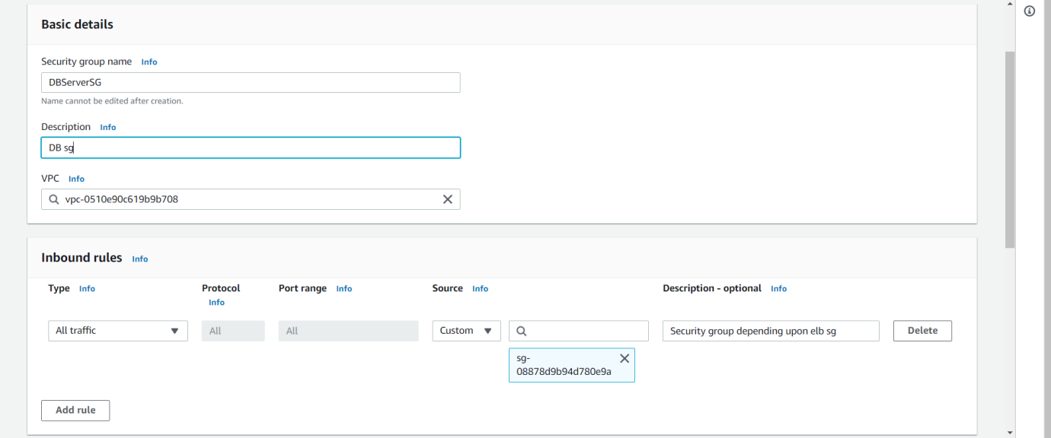

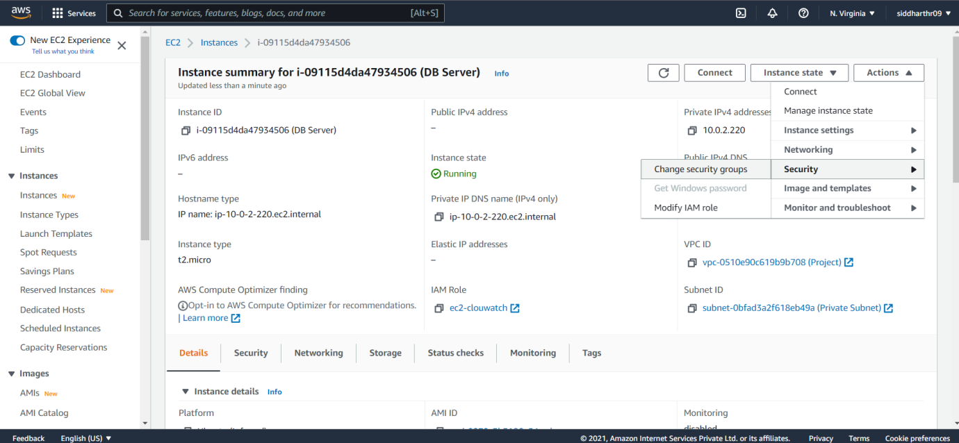

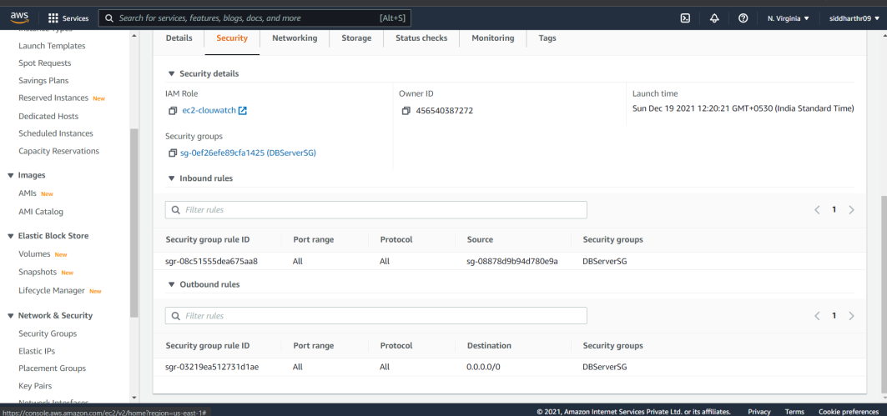

Testing:

For testing, created a new instance in the same subnet as the web servers. But not having the same security group.

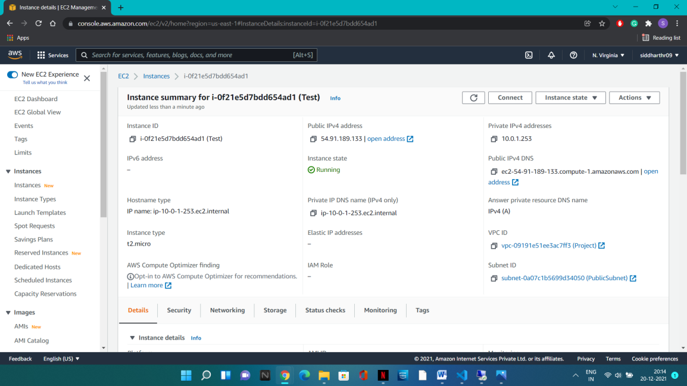

Testing connection form the test instance to web servers (working) and DB server (failed):

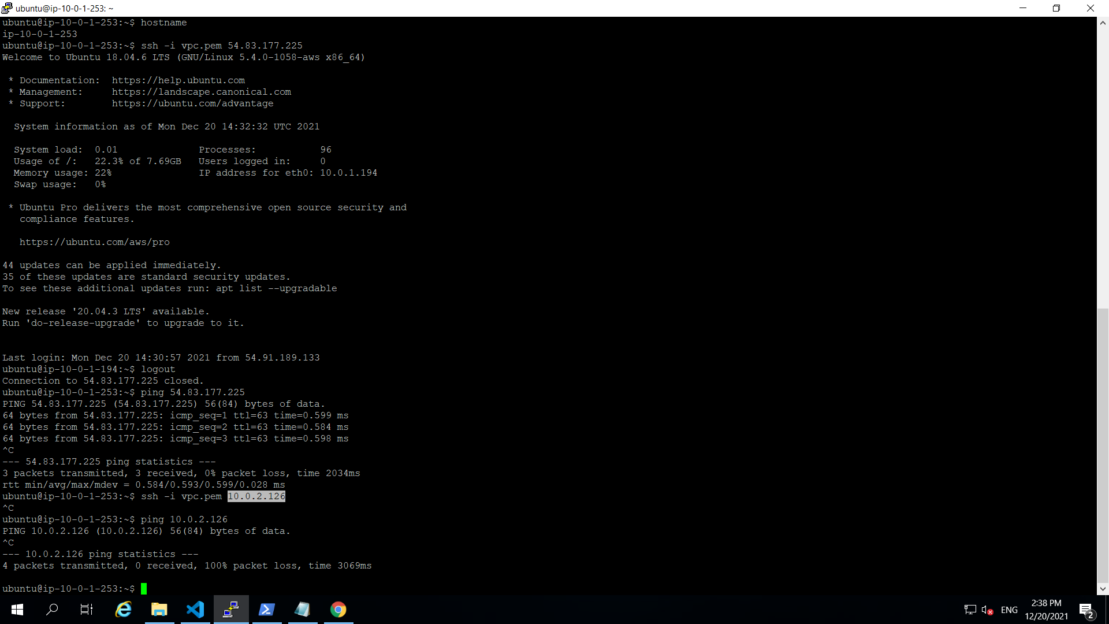

1. **Creating User:**

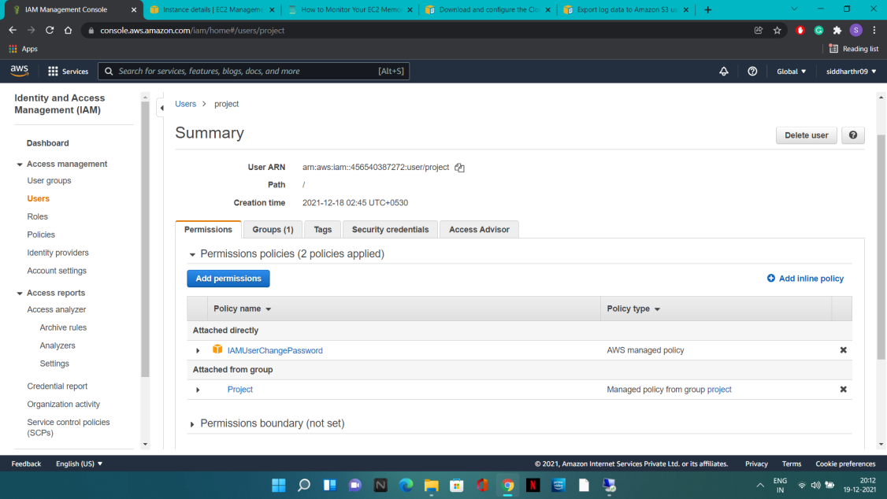

**Adding policies (EC2,VPC,Route53):**

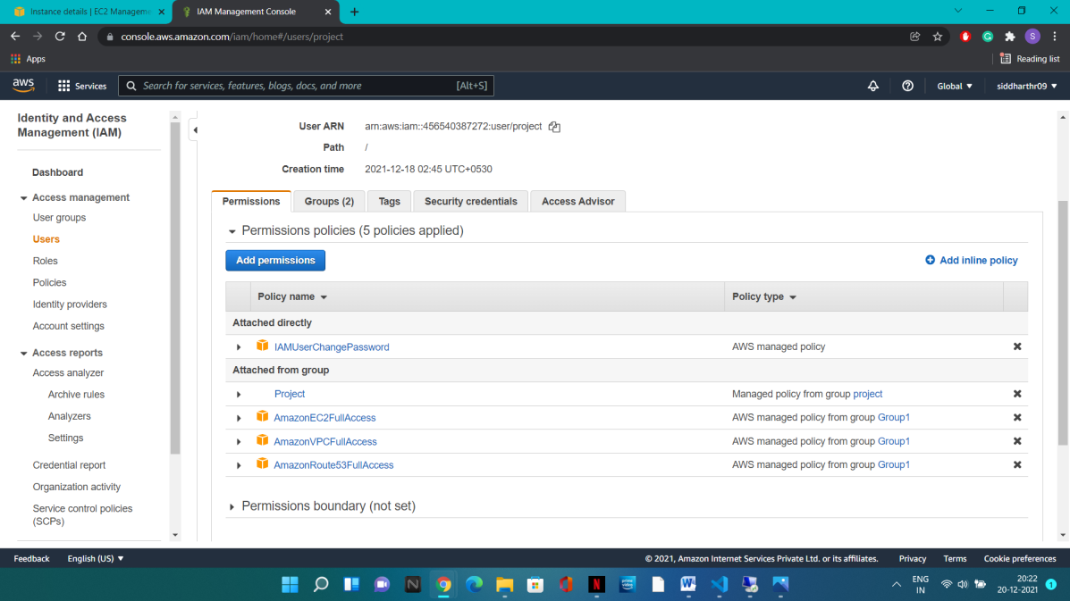

1. **Creating S3 Bucket to store logs:**

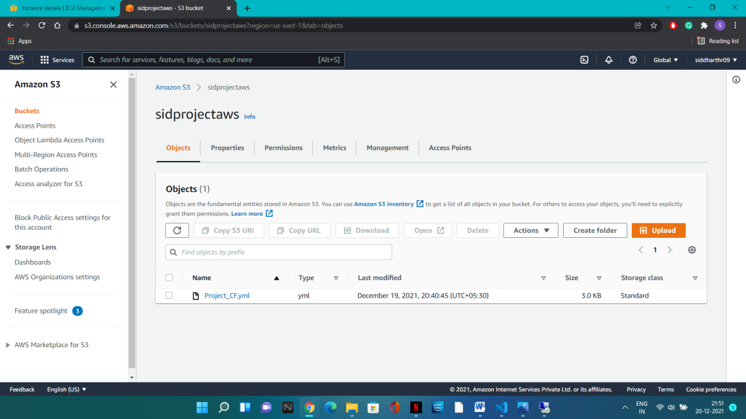

1. **S3 permission for EC2**

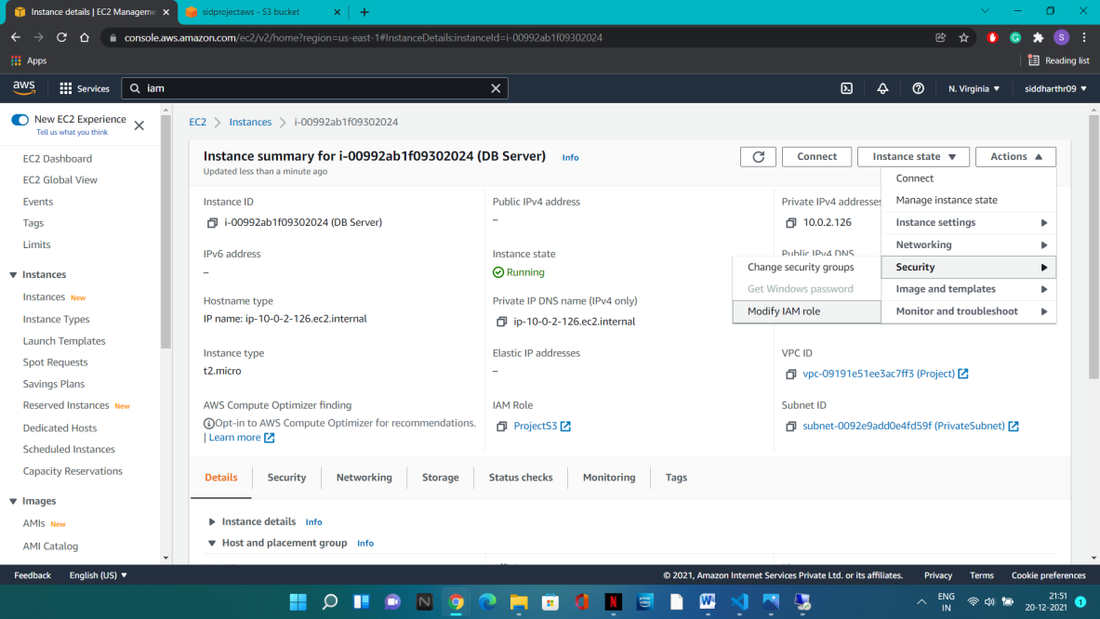

**Testing:**

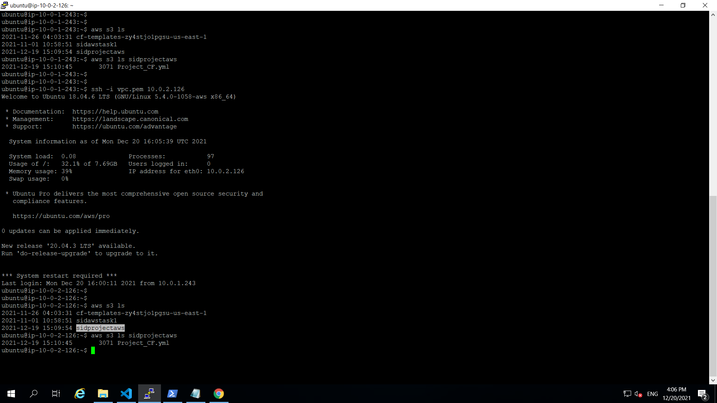

**Part 3:**

1. **Cloud Watch Dashboard:**

* **For EC2 (N/w, CPU Utilization, Disk usage) [Creating for 1 web instance for example]**

**Created Dashboard and added metrics from EC2 to it:**

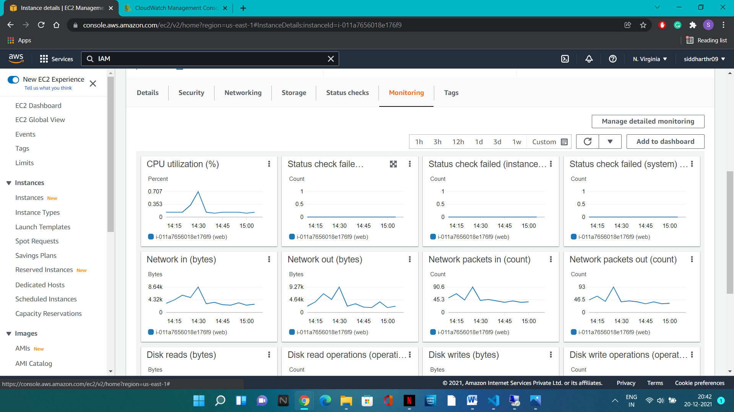

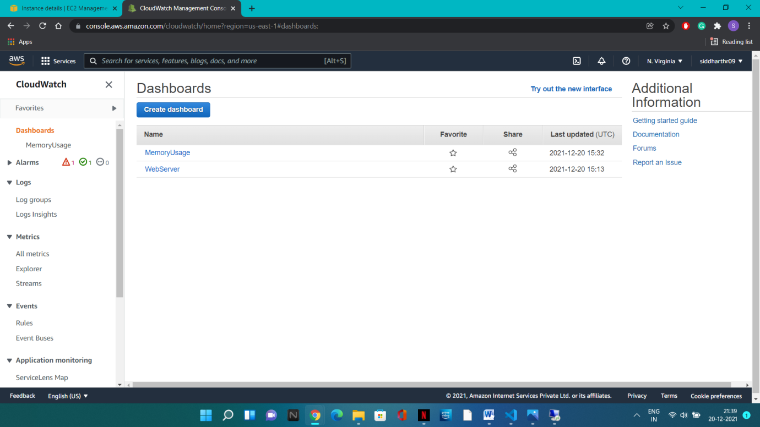

* **Created another Dashboard for Memory Usage monitoring:**

**Added Cloudwatch Full access role to EC2**

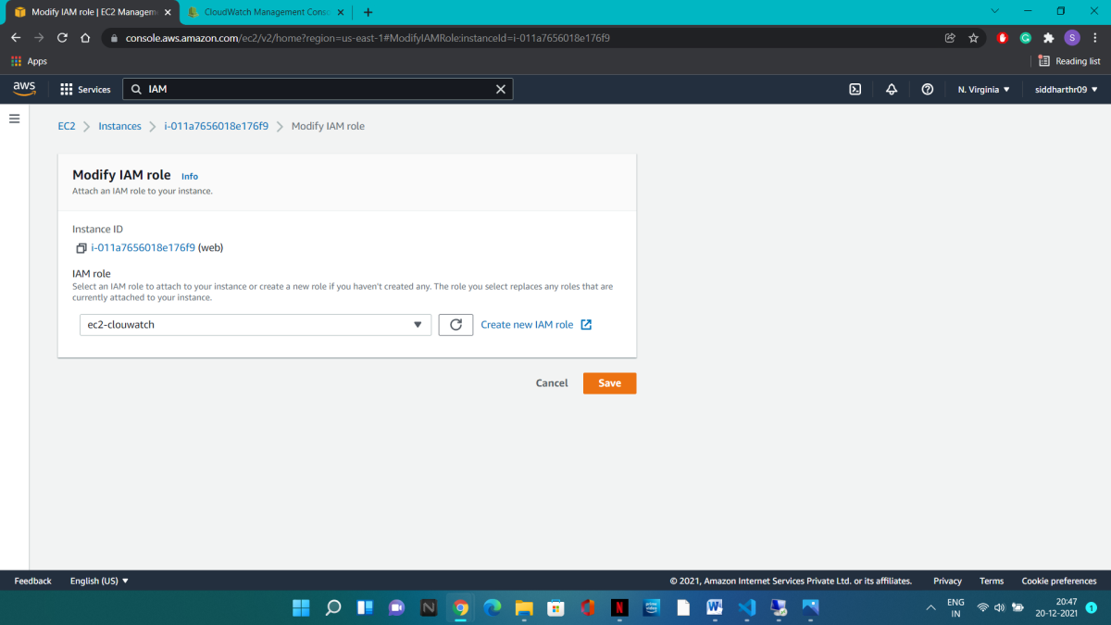

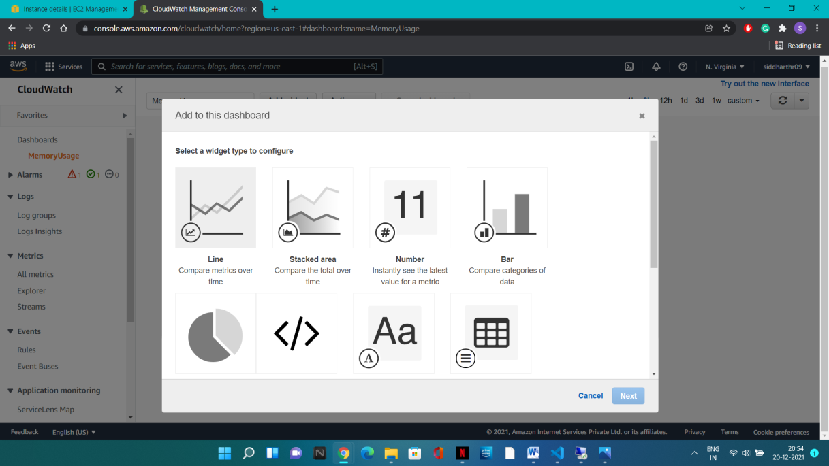

* **Downloaded Cloud Watch Agent to server**
* **Installed Cloud Watch Agent to server**
* **Configured config.json file to add desired metrics for memory to dashboard**

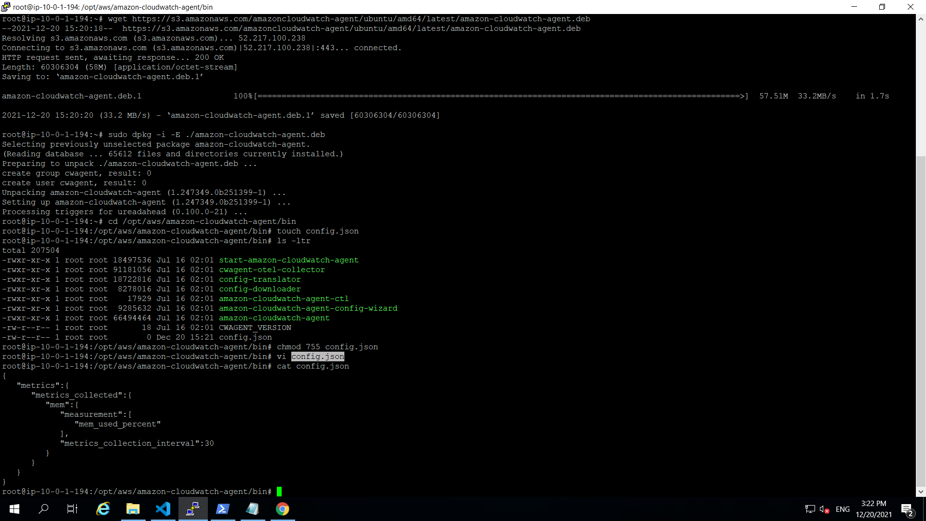

**Added CWAgent metrics to Memory Dashboard:**

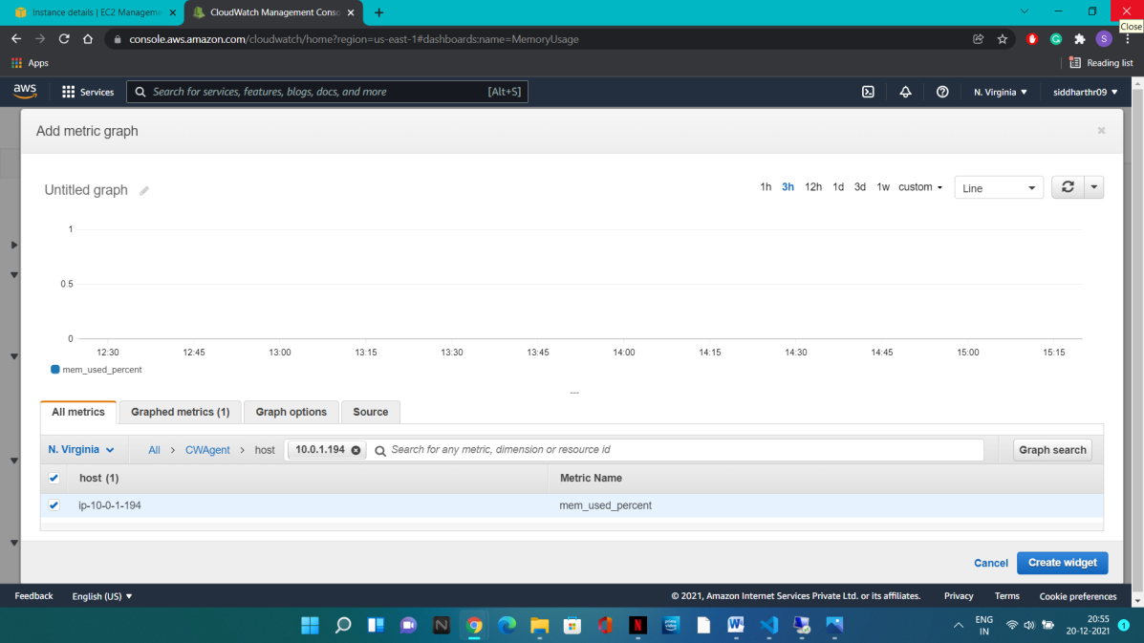

**Downloaded random file to check memory fluctuation:**

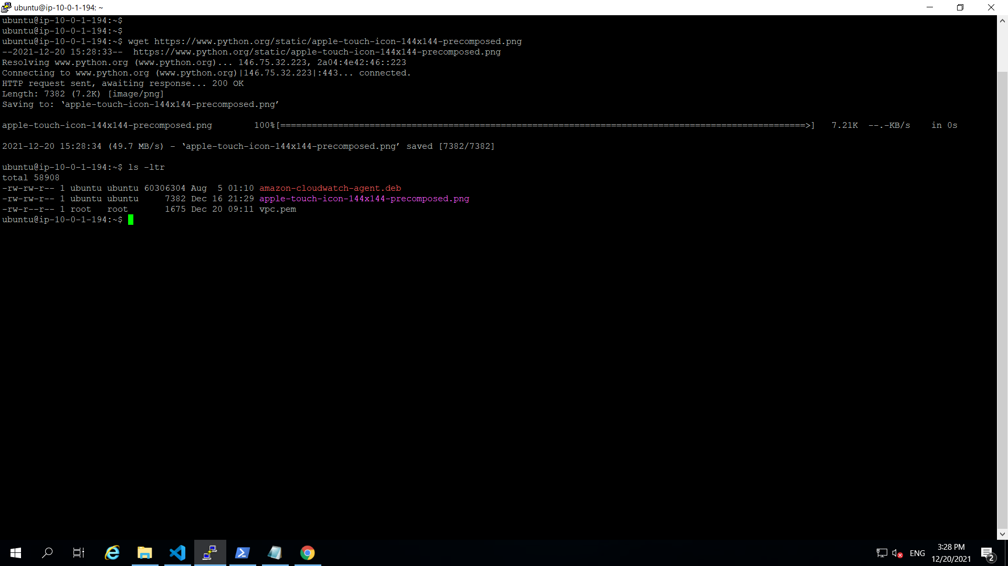

**Dashboard metrics showing memory usage:**

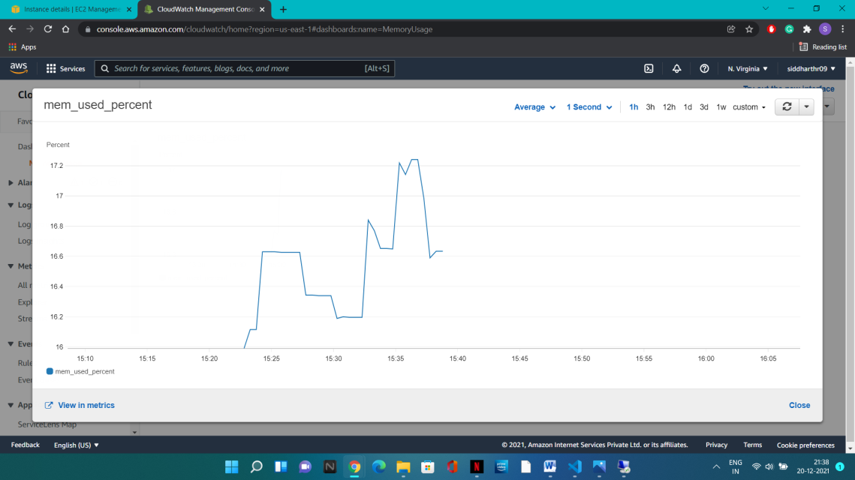

1. **Load Balancer traffic Monitoring:**

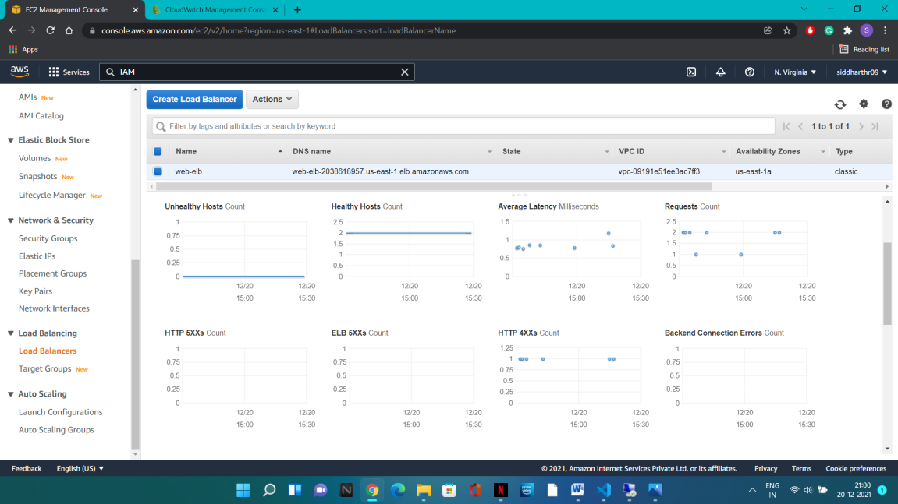

**Name:** Siddharth Rath

**EMPID:** SR00556869

**Link:** [**https://github.com/Sidax111/AWSproject-sid**](https://github.com/Sidax111/AWSproject-sid)